**Bangladesh University of Business and Technology (BUBT)**

Department of Computer Science and Engineering



**Project Report**

**Project Name:** Product collection and distribution system

## Team Member Name & ID

|  |  |
| --- | --- |
| **Name mobile no** | |
| **Md. Rakib Hasan** | 01996513255 |

**ACKNOWLEDGEMENT**

We take this occasion to thank the almighty for blessing us with his grace and taking our endeavor to a successful culmination. We extend our sincere and heartfelt thanks to our esteemed project adviser **Mr. Suman Saha**, Assistant Professor, Department of CSE, BUBT for his invaluable guidance during the ourse of this project work. We extend my sincere thanks to him for his continuously helped throughout the project and without his guidance, this project would have been an uphill task. Last but not the least; we would like to thank friends for the support and encouragement they have given us during the course of our work.

Md. Rakib Hasan

**ABSTRACT**

The purpose of this study is product distribution and collection system .Itmanagementmore easier than hand to hand supply. Through this system farmers can easily sell their products with fair price and the buyer will undoubtedly get the hygienic and quality product.  Nowadays this kind of application is very essential for business. This application will here to show the inventory setup, inventory management, PIMS setup, administrative, farmer info, product collection, shipment request and report. All the information is stored in database to see further days to judge everything. The technology platform in implementing this system uses Microsoft Visual studio 2013, MSSQL server 2008.

**INDEX**

|  |  |
| --- | --- |
| **Contents** | **Page** |
|  |  |
| Acknowledgement |  |
| Abstract |  |
| Tables of Contents |  |
| **Chapter:1 Introduction** |  |
| 1.1 Introduction | 5 |
| 1.2 Motivation | 6 |
| 1.3 Features | 6 |
| 1.5 Conclusion | 7 |
| **Chapter:2BACKGROUND KNOWLEDGE** |  |
| 2.1Introduction | 7 |
| 2.2Supporting tools | 7 |
| 2.2.1Microsoft Visual studio | 8 |
| 2.2.2Microsoft SQL server | 8 |
| 2.3 Conclusion | 8 |
| **Chapter:3 PROPOSED SYSTEM ANALYSIS AND DESIGN** |  |
| 3.1 Introduction | 9 |
| 3.2 System Analysis | 9 |
| 3.3 System Requirements | 10 |
| 3.4 Relational Database | 11 |
| 3.5 Structured Query Language (SQL) | 11 |
| 3.6 Main Database | 12 |
| 3.7 User Database Table | 13 |
| 3.8 Diagram | 14 |
| 3.9 Conclusion | 15 |
| **CHAPTER 4:USER MANUAL** |  |
| 4.1 Login option | 16 |
| 4.2 Administration | 16 |
| 4.3:Agent profile | 17 |
| 4.4 Inventory setup | 19 |
| 4.5 Inventory Management | 21 |
| 4.6 PIMS Setup | 23 |
| 4.10 Report | 24 |

**CHAPTER 1**

**INTRODUCTION**

**1.1 Introduction**

This application a supply chain management system (SCMS).Where farmers can easily sell their products with fair price and the buyer will undoubtedly get the hygienic and quality product.The main aim behind this project is to get hygienic product with fair price from farmer level, to manage details it will handle only the sales information and total stock states. The windows application records farmers list who sell their product by the agent then purchased items by customer and the amount of money through its category. This application will here to show the inventory setup, inventory management, PIMS setup, administrative, farmer info, product collection, shipment request and report. The main objective of this application is both parties get fair price and quality product. So that no syndicate or dishonest people can adulterate and increase the price of the product.

The system will do the following activities:

1. Add member for collecting the product.
2. Item collection.
3. Available, Non-available item list.
4. Making bill calculation
5. Total selling amount date to date
6. Make total bill.
7. Export bill as PDF.
8. Farmer get conformation sms after product collection.

**1.2Motivation**

The project aims to get the hygienic and quality product from the farmer and deliver them to buyers.The main objective of this application is both parties get fair price and quality product.The uniqueness is being desktop based application and for general-purpose. This system is available in a single computer.

**1.3 Features:**

1. Administration
   1. New user create
   2. User group setup
2. Agent profile
   1. farmer information
   2. product collection
   3. shipment request
   4. logout
3. Inventory setup
4. Product setup
5. Category setup
6. Subcategory setup
7. UOM setup
8. Inventory management
9. Purchase authorized
10. Product received
11. Product stock
12. Product distribution
13. PIMS Setup
14. New client
15. Report
    1. Purchase information
    2. Purchase status
    3. Product received information
    4. Sales information
    5. Stock information
    6. Profit and loss
16. Logout

**1.5 Conclusion:** Farmers, Dealers, Retailers and buyers will benefit financially by using Chain Management System and get hygienic and good quality product.

# **CHAPTER 2**

**BACKGROUND KNOWLEDGE**

**2.1Introduction:**

Management systems are developed on the purpose to overcome the problems that faced by manual method and it is also can ease up the user to do their daily work. Development of computer-based system provides more benefits and influences that can shape and create the work culture more systematic and can change the administrative structure of an organization to be more quickly and effectively. Hence, we would like to propose the idea of Supply chain Management System.Where farmers can easily sell their products with fair price and the buyer will undoubtedly get the hygienic and quality product.Through this system, user will be able to record all information about product stock, purchase information, farmer information etch into single database. Every data can be search, add, and also delete. Additionally, Restaurant Management System is easier to use.

**2.2Supporting tools:**

Many tools are used to develop the Windows application.Some of them are used for development purpose and some of them are part of this Windows application.

**2.2.1Microsoft Visual studio**

Microsoft Visual Studio integrated development environment(IDE) from Microsoft. It is used to develop computer program, as well as websites, desktop apps, web services and mobile apps. Visual Studio uses Microsoft software development platforms such as Windows API, windows forms, Windows presentation Foundation,Windows Store and Microsoft Silverlight. It can produce both native code and managed code.Visual Studio supports 36 different programming languages and allows the code editor and debugger to support (to varying degrees) nearly any programming language, provided a language-specific service exists. Built-in languages include C, C++, C++/CLI, VisualBasic.NET, C#, F#, JavaScript, TypeScript, XML, XSLT, HTML, and CSS. Support for other languages such as Python, Node.js, and M among others is available via plug-ins, Java (and J#) were supported in the past.

**2.2.2MicrosoftSQL server:**

Microsoft SQL Server is a relational database management system developed by Microsoft. As a database server it is a software product with the primary function of storing and retrieving data as requested by other software application—which may run either on the same computer or on another computer across a network (including the Internet).

# **2.3 Conclusion**

# In this page we learn about various tools that we use in our project such as

Microsoft Visual studio 2013, MSSQL server 2008.

# **CHAPTER 3**

**PROPOSED SYSTEM ANALYSIS AND DESIGN**

**3.1 Introduction**

Requirements analysis in systems engineering and Windows application engineering. Encompasses those tasks that go into determining the needs or conditions to meet for a new or altered product, taking account of the possibly conflicting requirements of the various stakeholders, such as beneficiaries or users. Another requirement you need to have to be a Windows application manager you need to know how to pleasure your boss. But in financing you also need to pleasure your boss . Requirements analysis is critical to the success of a development project. Requirements must be documented, actionable, measurable, testable, related to identified business needs or opportunities, and defined to a level of detail sufficient for system design. Requirements can be architectural, structural, behavioral, functional, and non-functional.

**3.2 System Analysis**

System analysis is the process of gathering and interpreting facts, diagnosing problems and using the information to recommend improvements on the system. System analysis is a problem- solving activity that requires intensive communication between the system users and system developers. System analysis or study is an important phase of any system development process. The system is viewed as a whole, the inputs are identified and the system is subjected to close study to identify the problem areas. The solutions are given as a proposal. The proposal is reviewed on user request and suitable changes are made. This loop ends as soon as the user is satisfied with the proposal.

The existing system is not totally automated. Though the system is computerized to a particular extent, it has not to do a lot of manual work. The different processes involved are:

1. User-friendly.
2. High security.
3. Easy data uploading.
4. Easy record keeping.
5. Backup data can be easily generated.

## 3.3 System Requirements

A Windows application requirements specification report basically describes and environment for windows application/application under development. It completely describes the yield, cost, nature of the windows application/application.

## 3.3.1Functional Requirements:

1. Systems will have 2 type of users called admin and agent.
2. System will have secure login option.
3. Admin view the product information, purchase information, stock information, profit and loss, sales information.
4. Agent add farmer and give shipment request to the admin.

## Non-Functional Requirements

Safety **Requirements**

If there is extensive damage to a wide portion of the database due to catastrophic failure, such as a disk crash, the recovery method restores a past copy of the database that was backed up to archival storage (typically tape) and reconstructs a more current state by reapplying or redoing the operations of committed transactions from the backed-up log, up to the time of failure.

**Security Requirements**

Security systems need database storage just like many other applications. However, the special requirements of the security market mean that vendors must choose their database partner carefully.

**Windows application Quality Attributes**

**Correctness:**

The system should generate an appropriate report about different activities of the mess and should keep track of all records.

**Maintainability:**

The system should maintain item and calculate item rate correctly.

**Usability:**

The system should satisfy a maximum number of user’s needs.

**3.4Relational Database Management System (RDBMS)**

A Relational Database Management System (RDBMS) is a Windows application system that provides access to a relational database. The Windows application system is a collection of Windows application applications that can be used to create, maintain, manage and use the database. A "relational database" is a database structured on the "relational" model.

**3.5Structured Query Language (SQL)**

The Structured Query Language (SQL) is the set of instructions used to interact with a relational database. Infect, SQL is the only language that most of the database actually understands. Whenever we interact with such a database, the Windows application translates our commands into SQL, statement that the database knows how to intercept. SQL has major three components.

1. Data Manipulation Language (DML)
2. Data Definition Language (DDL)
3. Data Control Language (DCL)

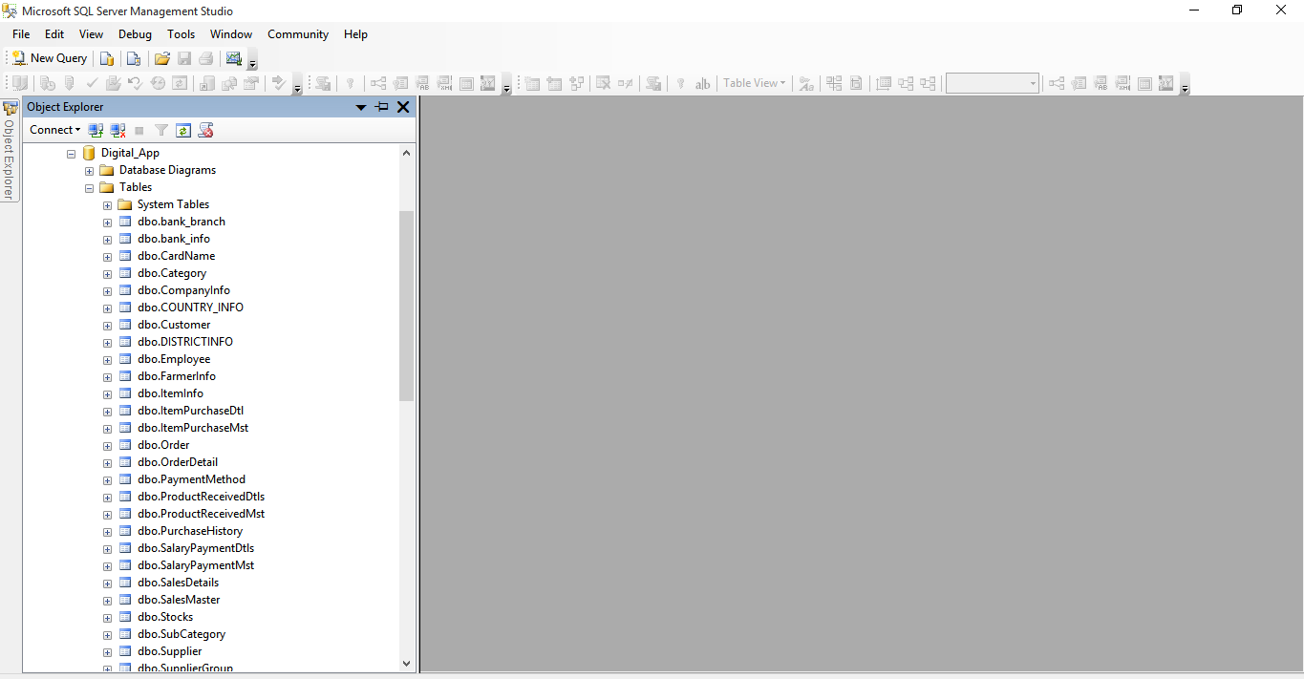**3.6 Main Database**

Figure 3.6: Main Database

**3.7User Database Table**

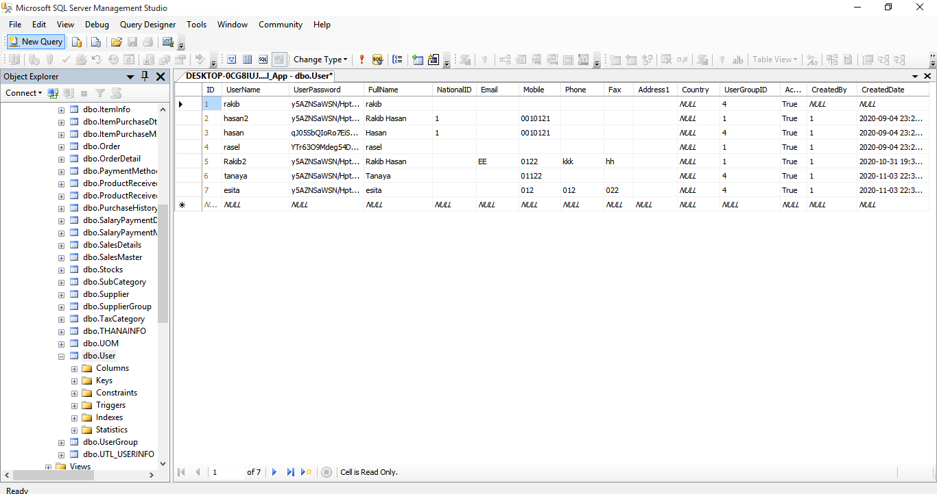

Figure 3.7: User Database Table

**3.8 Diagram:**

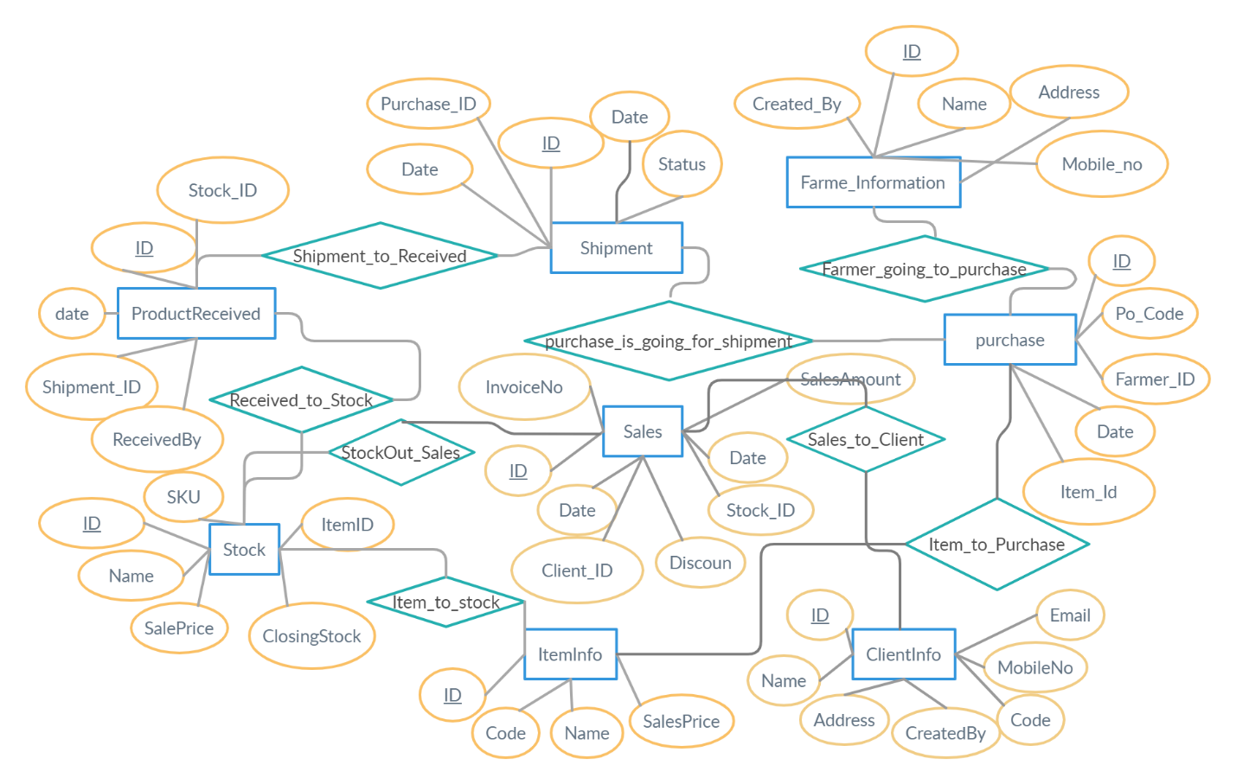

Figure 3.8.1 E-R Diagram

**3.9 Conclusion**

In this Section we analyst our System. WE discuss about our System Security also we discuss about database we use for our system and ER diagram. ER diagram show the relation between databases that we use to develop our system.

**CHAPTER 4**

**USER MANUAL**

**4.1 Login option:**

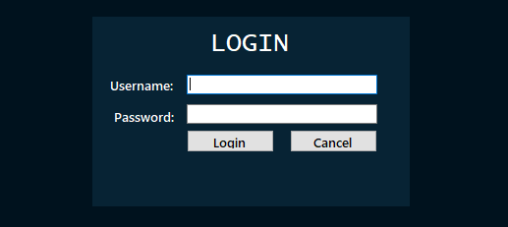Administrator, Agent,Operator & Others users use his own user name & Password to login. First of all only administrator can login in Application, then setup other users login Permissions.

.

Figure 4.1: login page

**4.2 Administration:**

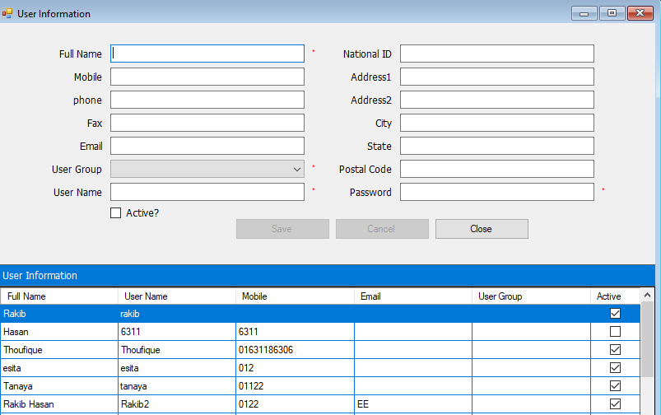**4.2.1 Administration:** Only the administrator can operate the application first. But the operator, the agent has to give permission from the panel created by the new user to run the application.

Figure 4.2.1: User information

**4.2.2 : User group setup:** This panel is used to set the role when adding a new member.

For example, is he an operator, agent, farmer or dealer.

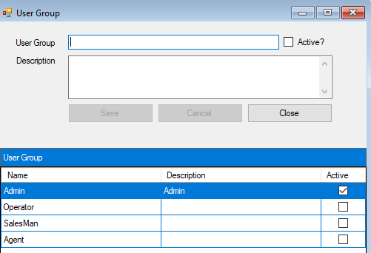

Figure 4.2.2: User Group Setup

**4.3 Agent profile:** Here Agent handle every matter, during field level to shipment.

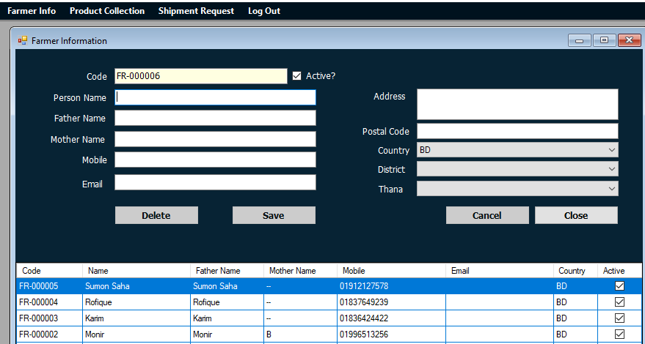**4.3.1 Farmer information:** When an agent's roll is created, the agent will first complete the farmer's profile with the farmer's detailed information (Name, Father name, mother name, phone number, email address, location etc.).

Figure 4.3.1: Farmer info

**4.3.2 Product collection**: This panel is used to collect products from farmers. From here, farmer name, product description and product price is insert and saved. As well as informing the farmer through SMS.

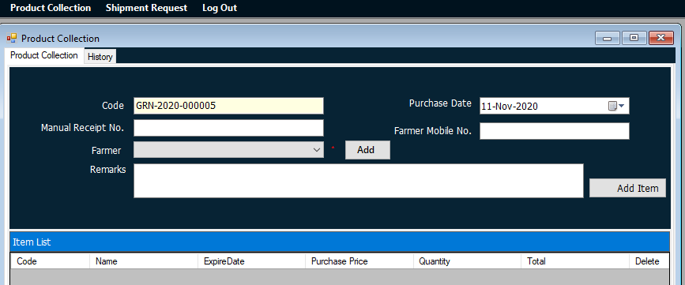

Figure 4.3.2:Product collection

**4.3.3 Shipment request:**The agent sends a request to the administrator for permission to purchase a product from the farmer through this panel.

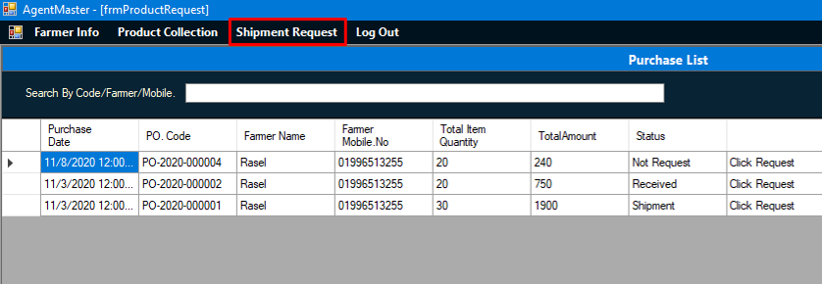

Figure 4.3.3:Shipment Request

**4.4 Inventory setup:**

Here many parts,some of them are.....

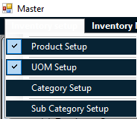

**4.4.1Product Setup:**

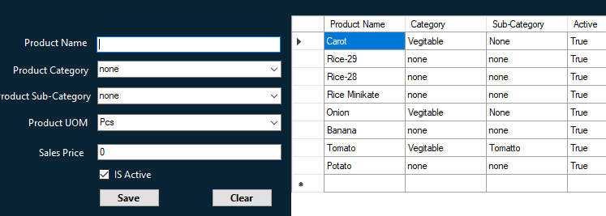

Figure 4.4.1: Product setup

**4.4.2 UOM:**UOM is used to add the units that are used according to the product.

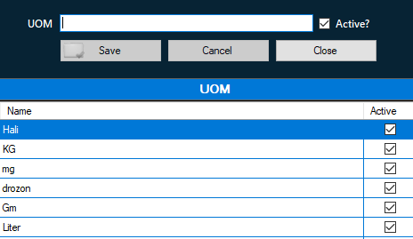

Figure 4.4.3:Unit of measurement

**4.4.3. Category Setup:**This menu has been used to create product categories. Such as: fruit, rice,fish, meat can be.

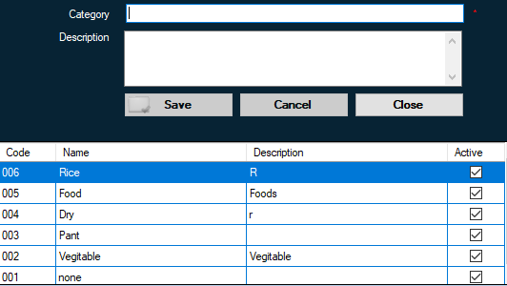

Figure 4.4.3:Category setup

**4.4.4. Sub Category Setup:**This menu has been used to create product Subcategories.Such as: Marine fish, haor fish, saltwater fishcan be.

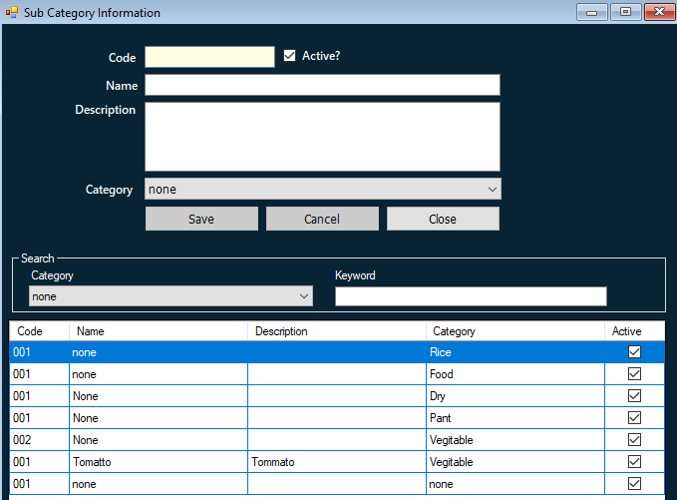

Figure 4.4.4: Category

**4.5 Inventory Management:**

**4.5.1. Purchase authorized:**After expecting a purchase request from the agent, a notification for permission comes to the administrator. The agent can purchase only if the administrator accepts the request.

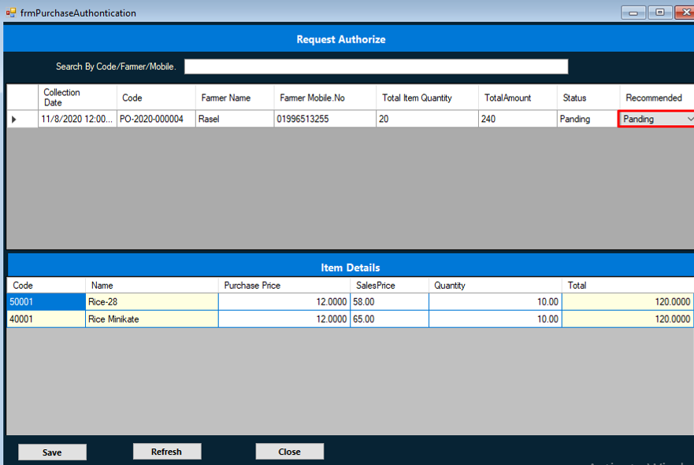

Figure 4.5.1: Purchase authorized

**4.5.2. Product received:**After purchasing the product, when the status changes, the products will bestored in the store.

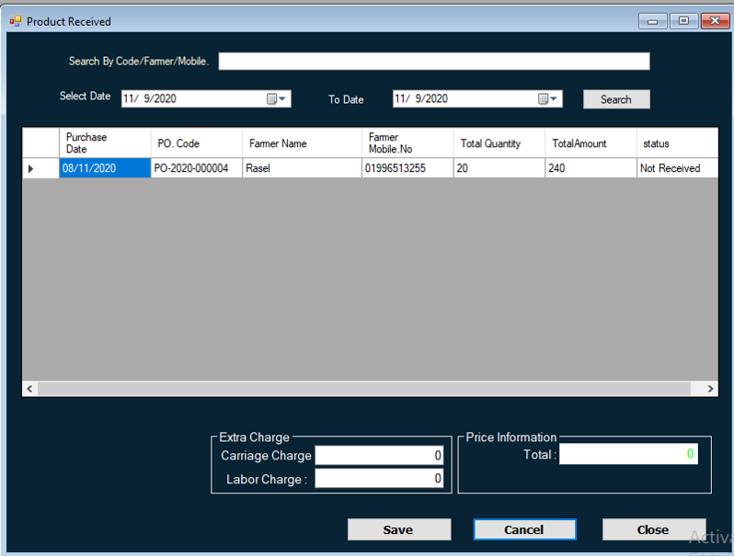

Figure 4.5.2: Product received

**4.5.3 Product stock:**The product stock panel is used to check the stock after purchasing and receiving the product. Detailed information of the product in stock is available from here.

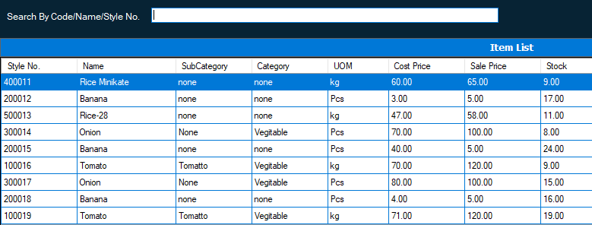

Figure 4.5.3: product stock.

**4.5.4 Product distribution:**Product distribution is the sale of goods directly to a retailer or dealer. From this panel the product is sold by calculating the price and discount with the detailed data of the product.

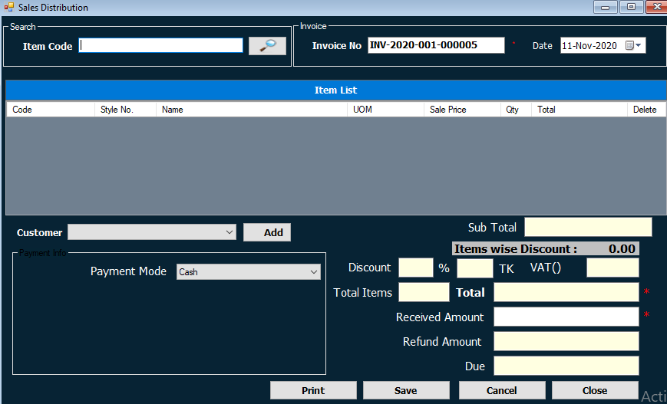

Figure 4.5.4: product distribution

**4.6 PIMS Setup:**

This panel is used to save the seller's information in advance to sellthe product to a new seller.

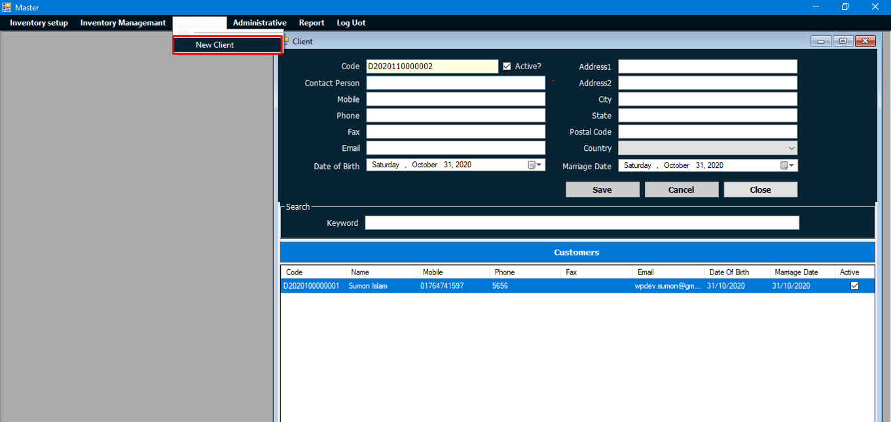

Figure 4.6 PIMS setup

**4.7 Report:** Sales information, purchase status, stock information, profit and loss reports are available from the report panel.

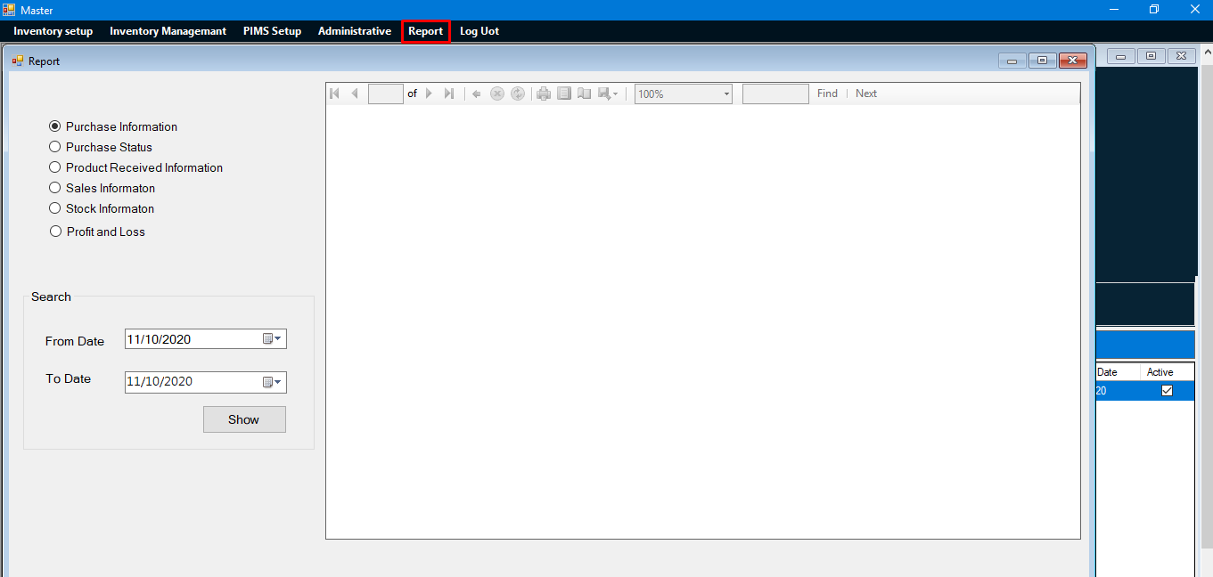

fig 4.10:Report

**4.11 Conclusion**

In this phase we talk about our system all functionalities such as inventory setup, inventory managment, PIMS setup, report etc. In this system we have so many options that will make the admin and agent much comfortable.During this phase, strict adherence was made on proven software engineering principles and practices.

**CHAPTER 5**

**CONCLUSION**

**5.1 Introduction**

To conclude the description about the project: The project developed using C# and MS SQL is based on he requirement specification of the user and the analysis of the existing system, with flexibility for future enhancement. The expanded functionality of today’s web application requires an appropriate approach towards web application development. This product collection and distribution management system web application is designed for farmer and buyer.Farmer get fair price and buyer get hygienic product.

**5.2 Future Works**

The project has a very fast scope in future. Project can be updated in near future as and when requirement for the same arises, as it is very flexible in terms of expansion. In future we add this system in mobile application

**REFFERENCES**

1. MS SQL Available at: <https://en.wikipedia.org/wiki/Microsoft_SQL_Server>

[last Visit: 2/11/2020]

1. w3schools Available at: <https://www.w3schools.com/cs/> [last Visit: 07/11/2020]
2. sqlservertutorial Available at: https://www.sqlservertutorial.net/ [last Visit: 07/11/2020]
3. tutorialspoint Available at: [https://www.tutorialspoint.com/csharp/index.htm[last](https://www.tutorialspoint.com/csharp/index.htm%5blast)

Visit: 07/11/2020]